SOLID Principles – Complete Guide for Backend Developers

1. Single Responsibility Principle (SRP)
Definition: A Class/Software component should have a single reason to change. It should have single responsibility.
Meaning: A class should do only one job.
Bad Design
Imagine a User Service doing everything:
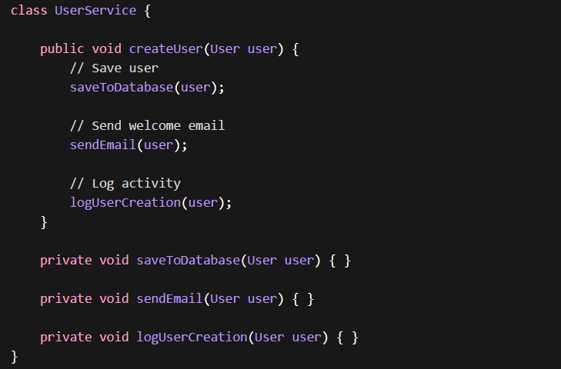
Problems:
- Hard to test
- Hard to modify
- Tight coupling
- One class doing multiple jobs

Correct Design (Following SRP)
Split responsibilities.
UserService
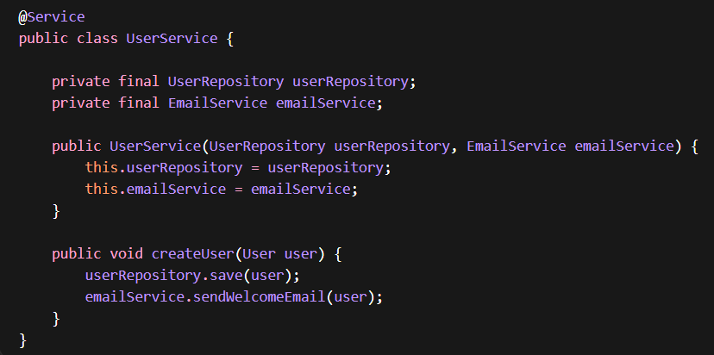
EmailService
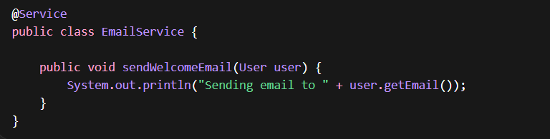
Responsibilities Now
Class | Responsibility
UserService | Manage user creation
UserRepository | Database operations
EmailService | Email sending

Each class has one reason to change.
2. Open Closed Principle (OCP)
Definition: Software entities should be Open for extension but closed for modification
Meaning: You should be able to add new functionality without modifying existing code.
Why?
Because modifying existing code can:
- introduce bugs
- break already tested features
- affect other modules
Instead, we extend behavior.
Problem Without OCP
Example: Payment processing
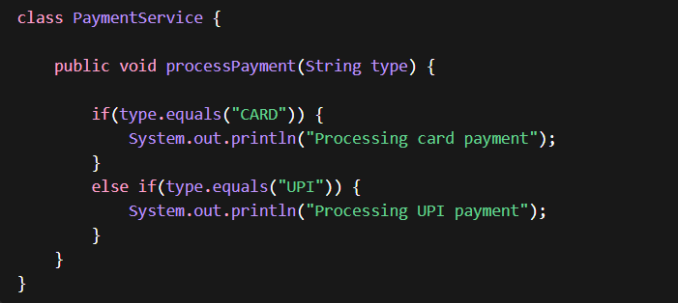
Problem: If tomorrow we add NetBanking, we must modify this class.
Every time:
This violates OCP because the class is not closed for modification.

Correct Design Using Polymorphism
Step 1 — Create Interface
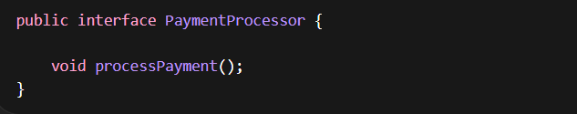
Step 2 — Implement Classes
Card Payment
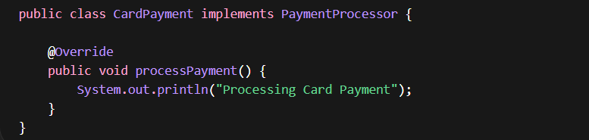
UPI Payment
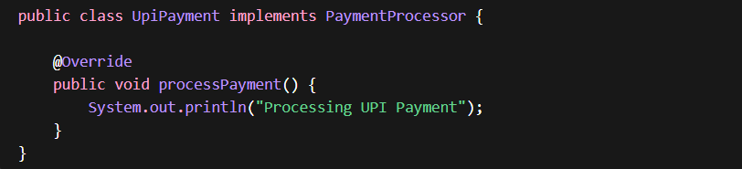
Wallet Payment
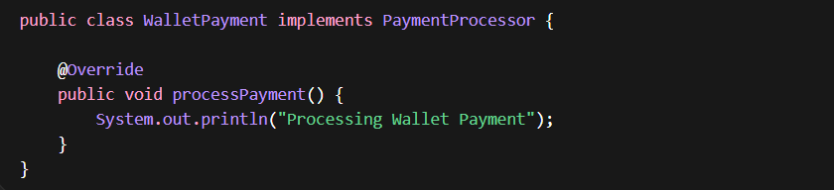

Step 3 — Payment Service
Now the service does not care about payment type.
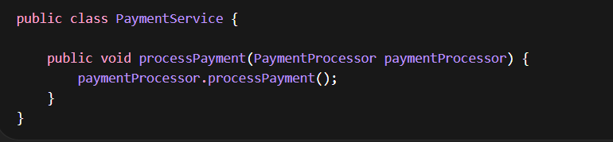
Step 4 — Using the Service
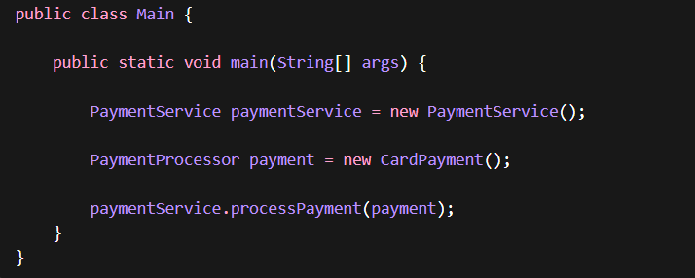
Step 5 — Add New Payment (No Code Modification)
Suppose you add NetBanking.
Just create a new class.
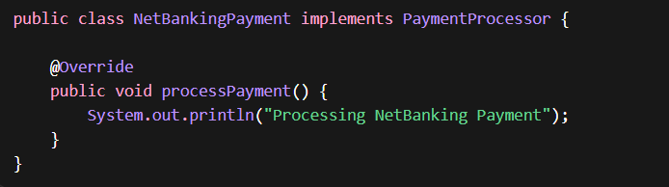
No existing code changes needed This is Open Closed Principle.
3. Liskov Substitution Principle (LSP)
Definition:
Subclasses should be replaceable with their base class without breaking behavior.
Meaning:
If a method expects A, it should work with:
- A
- B (child class)
- C (another child class)
without errors or different behavior.
Step 1 — Parent Class
Suppose we have a Bird.
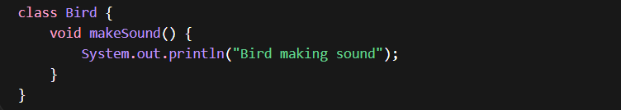
Step 2 — Subclasses
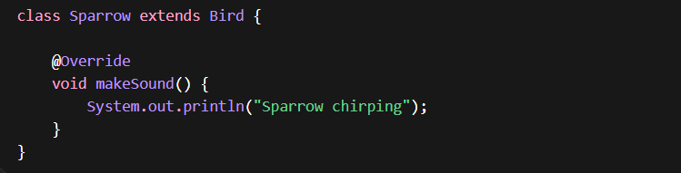
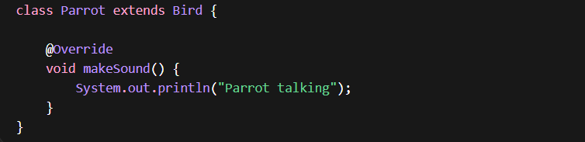
Step 3 — Method That Uses Parent Class
This method expects a Bird.
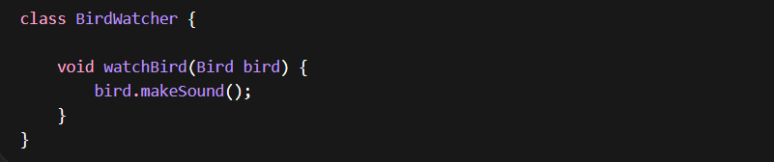
Important:
watchBird() expects Bird.
Step 4 — Replacing Parent with Subclasses
Now we pass different subclasses.
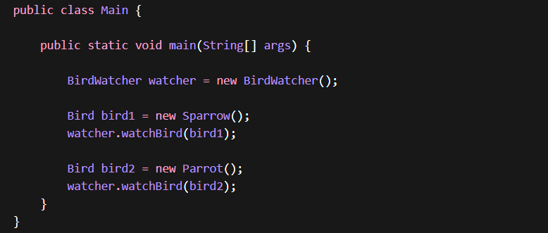
Notice something important:
The method expected Bird, but we passed:
- Sparrow
- Parrot
and everything worked perfectly.
This is Liskov Substitution Principle.

Example of LSP Violation
Suppose we create this subclass:
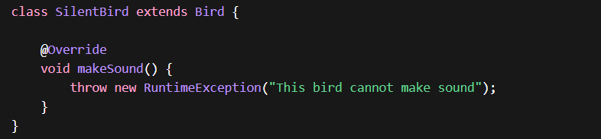
Now run:

Program crashes.
Why?
Because the method expected a normal Bird behavior, but the subclass broke it.
So SilentBird cannot replace Bird safely → LSP violated.

4. Interface Segregation Principle (ISP)
Definition
Clients should not be forced to depend on methods they do not use.
ISP states that larger interfaces need to be split into smaller interfaces. Because the implementation classes use only the methods that are required, we should not force the client to use the methods that they do not want to use.
In simple terms:
Instead of creating one large interface, create multiple small, focused interfaces.
Think of it like this:
❌ One big interface with many methods
✅ Many small interfaces with specific responsibilities
Bad Design (Violates ISP)
Suppose we create an interface for Workers.
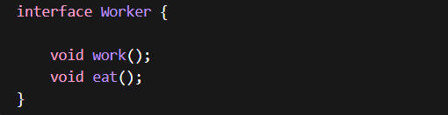
Now implement two workers.
Human Worker
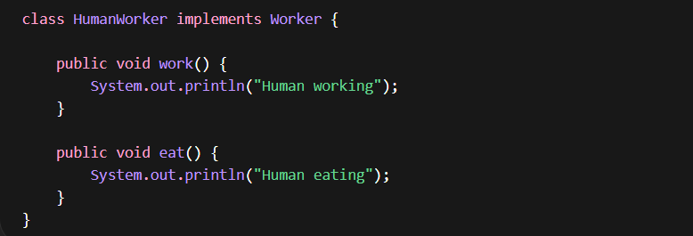
Robot Worker
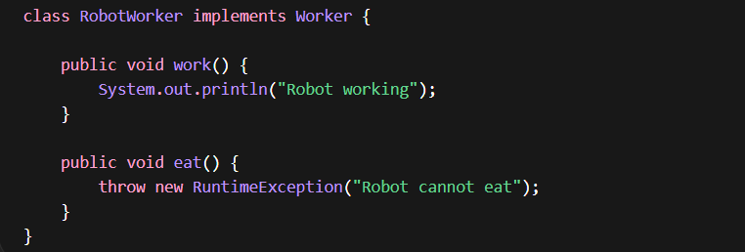
Problem:
Robot does not need eat(), but we forced it to implement.
This violates Interface Segregation Principle.
✅ Correct Design (Following ISP)
Split the interface into smaller ones.
Work Interface
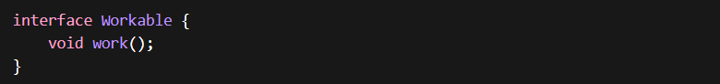
Eat Interface
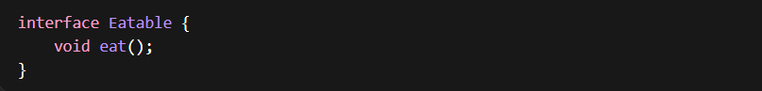
Human Worker
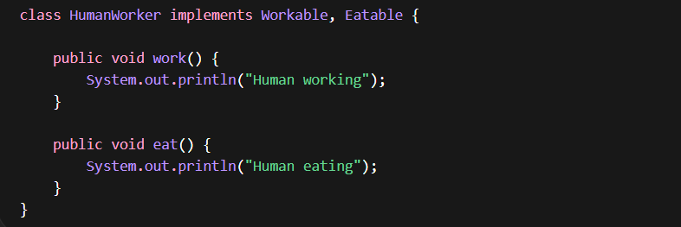
Robot Worker
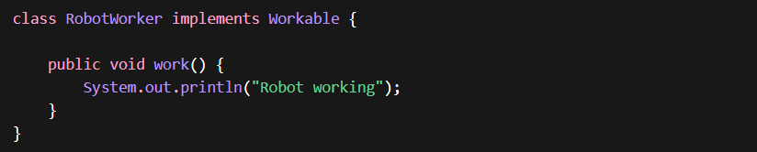
Now:
- Human → works + eats
- Robot → only works
No unnecessary methods This follows ISP.
5. Dependency Inversion Principle (DIP)
Definition
High-level modules should not depend on low-level modules.
Both should depend on abstractions.
This principle is the backbone of Spring Framework.
Spring’s Dependency Injection (DI) exists because of Dependency Inversion Principle
Instead of writing code like:
We should write:
This reduces tight coupling.

Bad Design (Violates DIP)
Service directly depends on MySQL implementation.
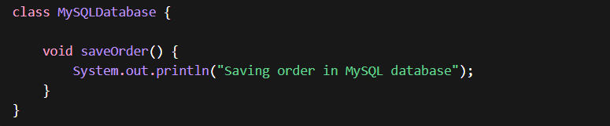
Service:
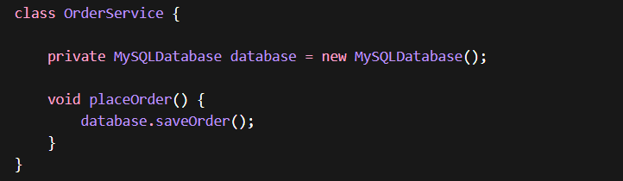
Now the system is tightly coupled.
If tomorrow we switch database:
- PostgreSQL
- MongoDB
- Oracle
We must change Order Service code. That is bad design.
Solution — Introduce Abstraction
Create an interface.
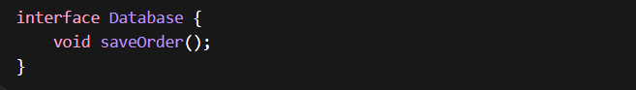
Concrete Implementations
MySQL
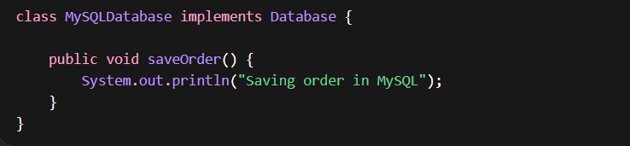
PostgreSQL
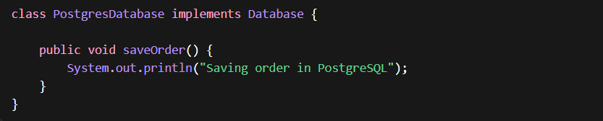
Service Depends on Abstraction
Now the service uses Database interface.
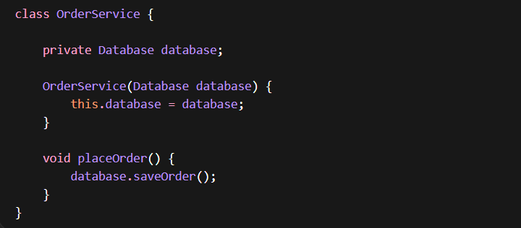
Notice something important:
Order Service doesn't know which database is used.
It only knows the Database interface.
Runtime Injection
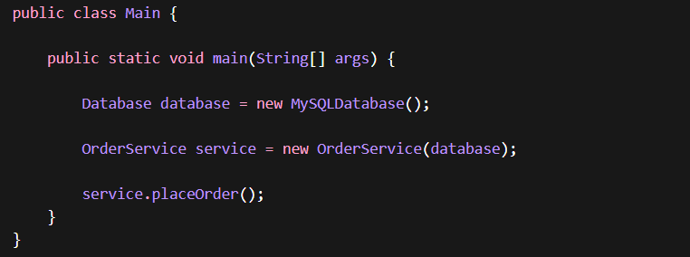
Output
If tomorrow we change DB:
Service code does not change This is Dependency Inversion Principle.
SOLID Principles in real Spring Boot Project
Typical Spring Boot Structure
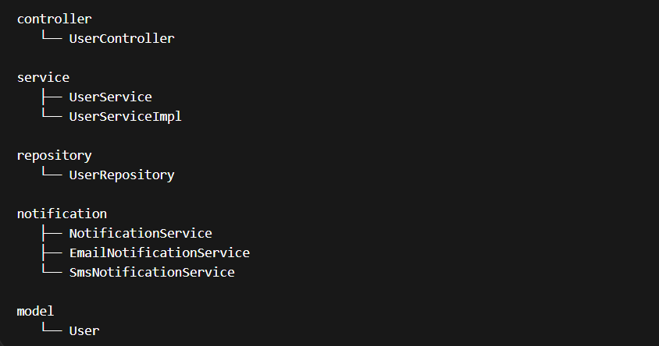
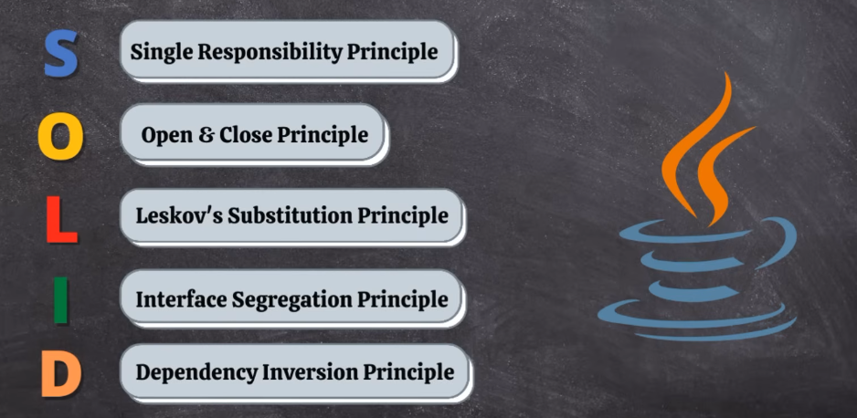
Now let's see where each SOLID principle appears

1️⃣ Single Responsibility Principle (SRP)
Each class has one responsibility.
Controller → handles HTTP request
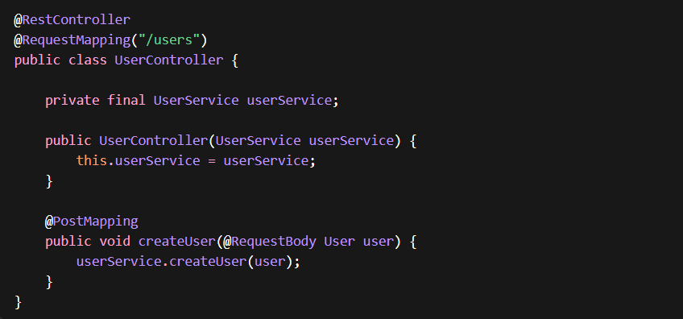
Responsibility: Controller → API handling
Service → business logic
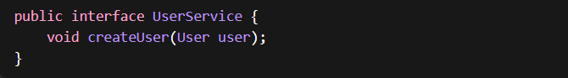
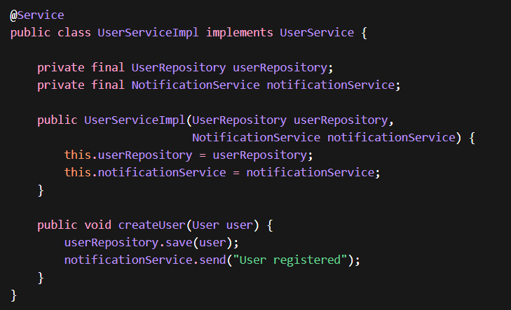
2️⃣ Open Closed Principle (OCP)
Systems should allow new features without modifying existing code.
Example: Notifications.
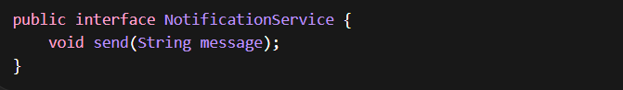
Email Implementation
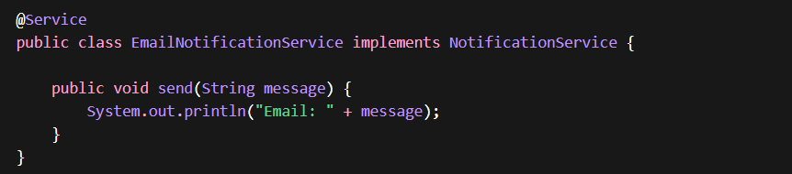
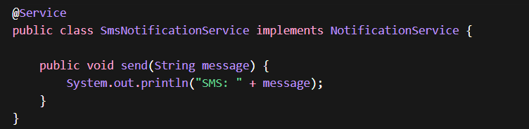
If tomorrow we add:
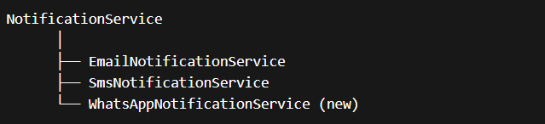
We don't modify existing classes.
That is OCP.
3️⃣ Liskov Substitution Principle (LSP)
Any implementation should replace the interface safely.
UserServiceImpl expects:
We can substitute: EmailNotificationService / SmsNotificationService
4️⃣ Interface Segregation Principle (ISP)
Instead of big interfaces, create small, focused ones.
Bad Design:
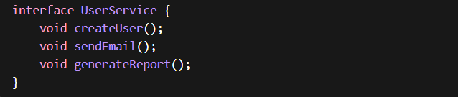
Better:
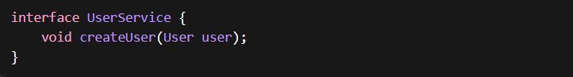
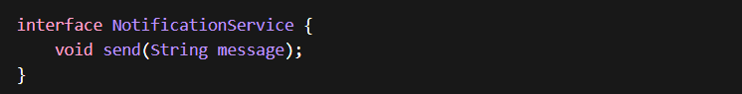

5️⃣ Dependency Inversion Principle (DIP)
High-level modules depend on interfaces, not implementations.
Ex:
Instead of:
Spring injects the implementation automatically.
This is DIP + Dependency Injection.
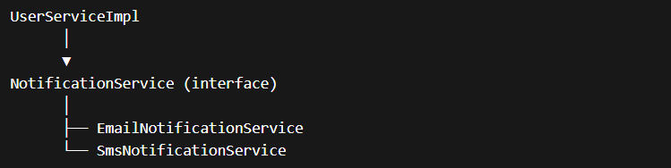
Quick SOLID Mapping
Principle | Where used
SRP | Controller, Service, Repository separation
OCP | Add new notification types without modifying code
LSP | Email/SMS can replace NotificationService
ISP | Small focused interfaces
DIP | Services depend on interfaces

If interviewer asks:
How does Spring Boot follow SOLID principles?
You can say:
Ans:
Spring Boot applications naturally align with SOLID principles through their layered architecture and use of dependency injection. Typically, the application is structured into layers such as Controller, Service, and Repository, where each layer has a clearly defined responsibility. Controllers manage HTTP requests and responses, services encapsulate business logic, and repositories handle data access. This separation ensures that each component has a single responsibility and remains easy to maintain and test.
Spring also encourages programming to abstractions rather than concrete implementations. Services usually depend on interfaces, while the actual implementations are injected by the Spring container through dependency injection. This design enables loose coupling, making it easy to substitute implementations, extend functionality, or integrate new components without modifying existing code.
Additionally, by defining focused interfaces and modular components, Spring Boot applications avoid large, monolithic contracts and instead promote smaller, purpose-driven abstractions. As a result, systems built with Spring Boot are easier to extend, test, and scale, while adhering closely to SOLID design principles.

